**Dutch residential mortgage market**

The Dutch residential mortgage debt stock is relatively sizeable, especially when compared to other European countries. Since the 1990s, the mortgage debt stock of Dutch households has grown considerably, mainly on the back of mortgage lending on the basis of two incomes in a household, the introduction of tax-efficient product structures such as mortgage loans with deferred principal repayment vehicles and interest-only mortgage loans, financial deregulation and increased competition among originators. Moreover, Loan-to-Value (LTV) ratios have been relatively high, as the Dutch tax system implicitly discouraged amortisation, due to the tax deductibility of mortgage interest payments. The mortgage debt growth continued until Q4 2012, when total Dutch mortgage debt stock peaked at EUR 652 billion[1]. The correction on the housing market caused a modest decline in mortgage debt in subsequent years, but as the market has been recovering since 2013, there is recently again a tendency to higher debt growth visible. In Q2 2015, the mortgage debt stock of Dutch households equalled EUR 635 billion1.

*Tax system*

The Dutch tax system plays an important role in the Dutch mortgage market, as it allows for full deductibility of mortgage interest payments from taxable income. This tax system has been around for a very long time, but financial innovation has resulted in a greater leverage of this tax benefit. From the 1990s onwards until 2001, this tax deductibility was unconditional. In 2001 and 2004, several conditions have been introduced to limit the usage of tax deductibility, including a restriction of tax deductibility to the (mortgage interest payments for) the borrower’s primary residence and a limited duration of the deductibility of 30 years.

A further reform of the tax system was enforced on 1 January 2013. Since this date, all new mortgage loans have to be repaid in full in 30 years, at least on an annuity basis, in order to be eligible for tax relief (linear mortgage loans are also eligible). The tax benefits on mortgage loans, of which the underlying property was bought before 1 January 2013, have remained unchanged and are grandfathered, even in case of refinancing and relocation. As such, new mortgage originations still include older loan products, including interest-only. However, any additional loan on top of the borrower’s grandfathered product structure, has to meet the mandatory full redemption standards to allow for tax deductibility.

Another reform imposed in 2013 to reduce the tax deductibility is to lower the maximum deduction percentage. This used to be equal to the highest marginal tax bracket (52%), but since 2013 the maximum deduction is lowered by 0.5% per annum to 38.0% in 2042 (2015: 51.0%).

There are several housing-related taxes which are linked to the fiscal appraisal value (“WOZ”) of the house, both imposed on national and local level. Moreover, a transfer tax (stamp duty) of 2% is applied when a house changes hands. Although these taxes partially unwind the benefits of tax deductibility of interest payments, and several restrictions to this tax deductibility have been applied, tax relief on mortgage loans is still substantial.

*Loan products*

The Dutch residential mortgage market is characterised by a wide range of mortgage loan products. In general, three types of mortgage loans can be distinguished.

Firstly, the “classical” Dutch mortgage product is an annuity loan. Annuity mortgage loans used to be the norm until the beginning of the 1990s, but they have returned as the most popular mortgage product in recent years. Reason for this return of annuity mortgage loans is the tax system. Since 2013, tax deductibility of interest payments on new loans is conditional on full amortisation of the loan within 30 years, for which only (full) annuity and linear mortgage loans qualify.

Secondly, there is a relatively big presence of interest-only mortgage loans in the Dutch market. Full interest-only mortgage loans were popular in the late nineties and in the early years of this century. Mortgage loans including an interest-only loan part were the norm until 2013, and even today, grandfathering of older tax benefits still results in a considerable amount of interest-only loan origination.

Thirdly, there is still a big stock of mortgage products including deferred principal repayment vehicles. In such products, capital is accumulated over time (in a tax-friendly manner) in a linked account in order to take care of a bullet principal repayment at maturity of the loan. The principal repayment vehicle is either an insurance product or a bank savings account. The latter structure has been allowed from 2008 and was very popular until 2013. Mortgage loan products with insurance-linked principal repayment vehicles used to be the norm prior to 2008 and there is a wide range of products present in this segment of the market. Most structures combine a life-insurance product with capital accumulation and can be relatively complex. In general, however, the capital accumulation either occurs through a savings-like product (with guaranteed returns), or an investment-based product (with non-guaranteed returns).

A typical Dutch mortgage loan consists of multiple loan parts, e.g. a bank savings loan part that is combined with an interest-only loan part. Newer mortgage loans, in particular those for first-time buyers after 2013, are full annuity and often consists of only one loan part. Nonetheless, tax grandfathering of older mortgage loan product structures still results in the origination of mortgage loans including multiple loan parts.

Most interest rates on Dutch mortgage loans are not fixed for the full duration of the loan, but they are typically fixed for a period between 5 and 15 years. Rate term fixings differ by vintage, however. More recently, there has been a bias to longer term fixings (10-20 years). Most borrowers remain subject to interest rate risk, but compared to countries in which floating rates are the norm, Dutch mortgage borrowers are relatively well-insulated against interest rate fluctuations.

*Underwriting criteria*

Most of the Dutch underwriting standards follow from special underwriting legislation (“Tijdelijke regeling hypotecair krediet”). This law has been present since 2013 and strictly regulates maximum LTV and Loan-to-Income (LTI) ratios. The current maximum LTV is 103% (including all costs such as stamp duties), but it will be gradually lowered to 100% by 2018, by 1% per annum. LTI limits are set according to a fixed table including references to gross income of the borrower and mortgage interest rates. This table is updated annually by the consumer budget advisory organisation “NIBUD” and ensures that income after (gross) mortgage servicing costs is still sufficient to cover normal costs of living.

Prior to the underwriting legislation, the underwriting criteria followed from the Code of Conduct for Mortgage Lending, which is the industry standard. This code, which limits the risk of over crediting, has been tightened several times in the past decade. The 2007 version of the code included a major overhaul and resulted in tighter lending standards, but deviation in this version was still possible under the “explain” clause[2]. In 2011, another revised and stricter version of the Code of Conduct was introduced. Moreover, adherence to the “comply” option was increasingly mandated by the Financial Markets Authority (*AFM*). Although the Code of Conduct is currently largely overruled by the underwriting legislation, it is still in force. The major restriction it currently regulates, in addition to the criteria in the underwriting legislation, is the cap of interest-only loan parts to 50% of the market value of the residence. This cap was introduced in 2011 and is in principle applicable to all new mortgage contracts. A mortgage lender may however diverge from the cap limitation if certain conditions have been met.

**Recent developments in the Dutch housing market**

The Dutch housing market has shown clears signs of recovery since the second half of 2013. Existing house prices (PBK-index) continued to increase in the third quarter of 2015, by 1.3 per cent on a quarterly basis. This is in line with the rise in sales numbers. Compared to a year ago, prices also rose (2.9 per cent.). Nonetheless, by comparison with the peak in 2008, the average price drop amounts to 16.5 per cent.

In the third quarter of 2015, the upward momentum in housing sales was maintained. The Land Registry registered a total of 50,609 transactions, which was the highest number in the third quarter since 2008. Forward looking indicators, such as the sales figures by the Dutch association of real estate agents (NVM), suggest that the more positive sales momentum will prevail in the fourth quarter of 2015.

**Forced sales**

Compared to other jurisdictions, performance statistics of Dutch mortgage loans show relatively low arrears and loss rates[3]. The most important reason for default is relationship termination, although the increase in unemployment following the economic downturn in recent years is increasingly also a reason for payment problems. The ultimate attempt to loss recovery to a defaulted mortgage borrower is the forced sale of the underlying property.

For a long time, mortgage servicers opted to perform this forced sale by an auction process. The advantage of this auction process is the high speed of execution, but the drawback is a discount on the selling price. In 2014, the Dutch Land Registry (“Kadaster”) recorded 2,178 forced sale by auction. This number is slightly higher than in 2013, but the trend in such auctions is roughly stable over recent years. As house prices have fallen between 2008 and 2013, and loss-given-defaults are no longer zero, originators increasingly attempt to circumvent such forced sales by auction, for example by selling the property in the normal market using an estate agent.

Chart 1: Total mortgage debt Chart 2: Sales and prices

 

*Source: Dutch Central Bank Source: Statistics Netherlands*

Chart 3: Price index development Chart 4: Interest rate on new mortgage loans

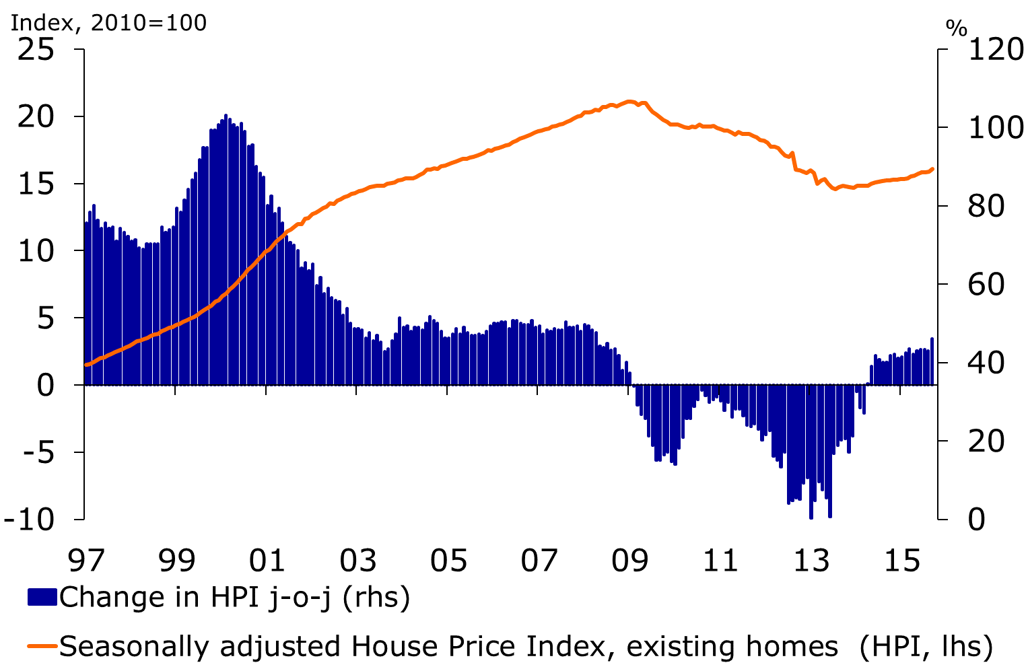

*Source: Statistics Netherlands Source: Dutch Central Bank*

Chart 5: New mortgage loans by interest type Chart 6: Confidence points to rise in sales

 

*Source: Dutch Central Bank Source: Delft University OTB, Rabobank*

1. Dutch Central Bank. Statistics table 11.1: Aggregate household balance sheet
2. Under the “explain” clause it is in exceptional cases possible to deviate from the loan-to-income and loan-to-value rules set forth in the Code of Conduct
3. Comparison of S&P RMBS index delinquency data